Enable Versioning on S3 Bucket and Create Rule to move to AWS Glacier

CREATE AN S3 BUCKET
🔹 Step 1: Open S3
- Go to AWS Console
- Search for S3
- Click Create bucket

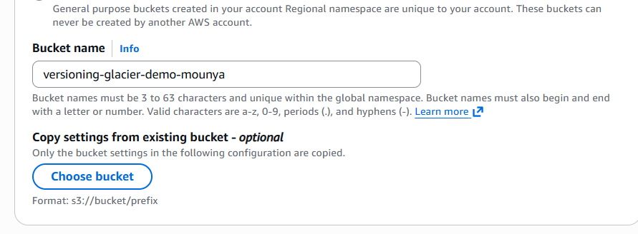
• Scroll to Bucket Versioning
• Click Edit
• Select:
Enable
• Click Save changes

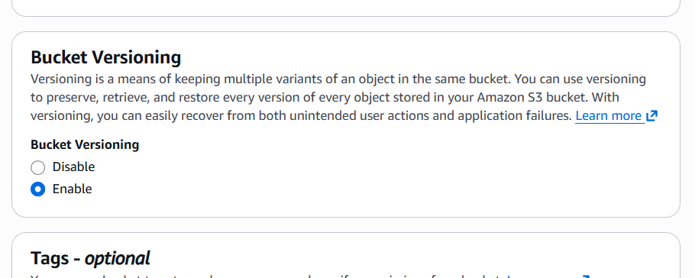

Go to Management tab
- Inside the bucket
- Click Management

🔹 Step 6: Create Lifecycle Rule
- Under Lifecycle rules
- Click Create lifecycle rule

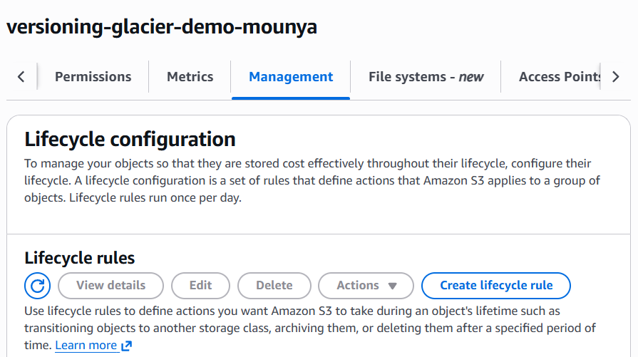

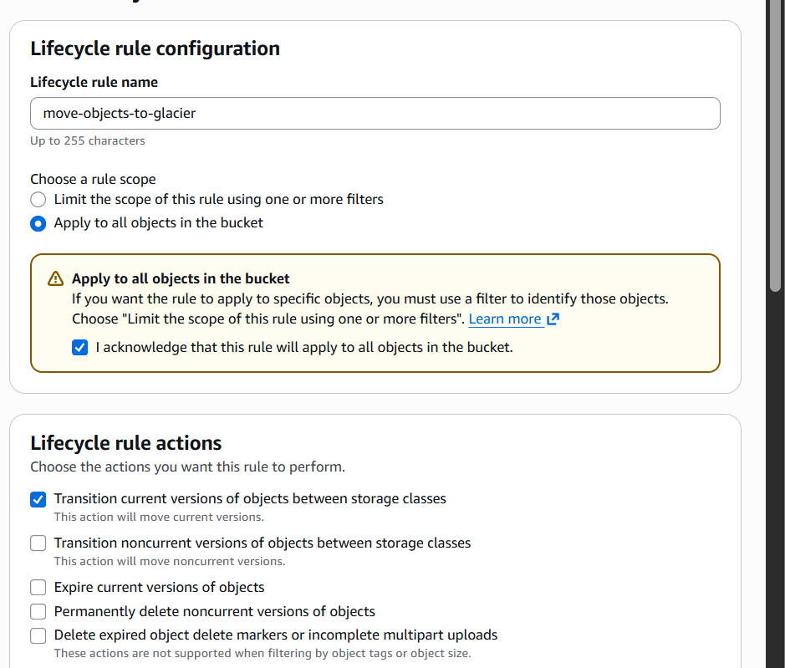

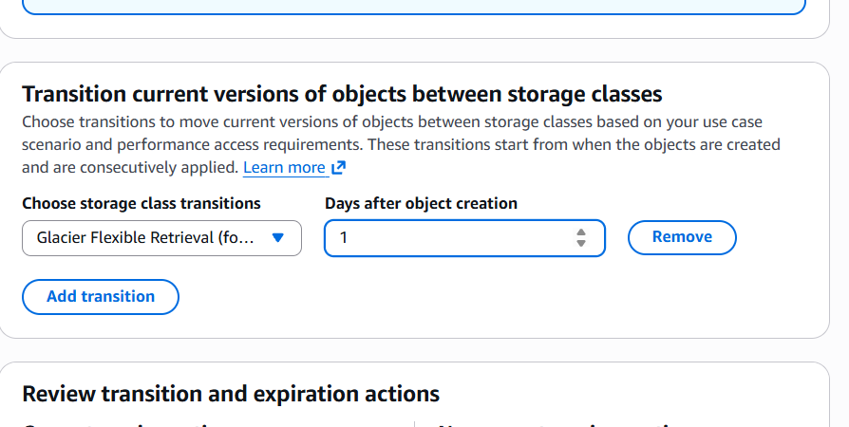

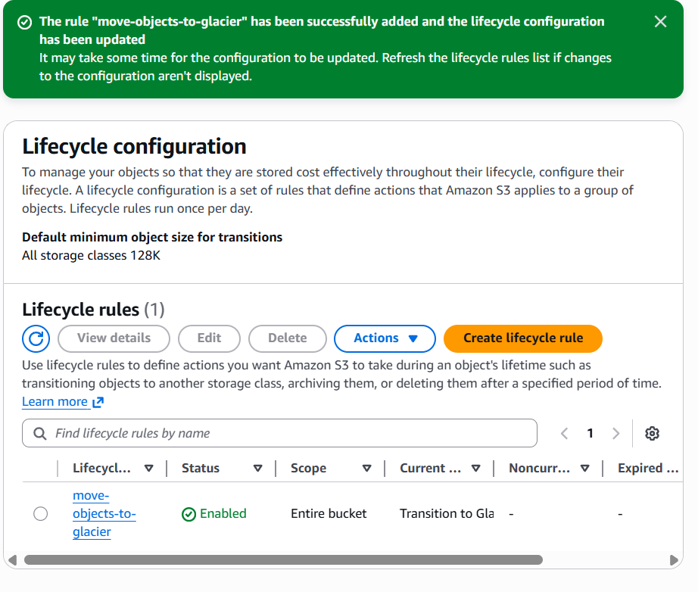

After the rule is created:
- Go to S3 → Your bucket
- Open the Management tab
- Under Lifecycle rules, you should see:
- move-objects-to-glacier
→ Transition to Glacier after 1 day
“The minimum time taken to transition an object is 1 day, this use case cannot be realized fully.”

